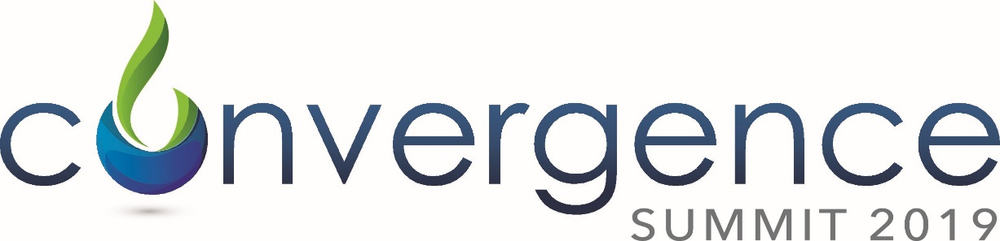

Connecting theory and reality in business communication
Thursday, March 28, 2019
McNamara Alumni Center at the University of MN

Call for Presenters

The Convergence Summit debuted in 2015 from the need to get a larger look at the communication profession since business communication practices, messages, channels and creators had morphed and changed over time. How do we make sense of this convergence? The Convergence Summit brings together experts from both the business and academic realms to explore the changes and challenges convergence presents for business communicators.

IABC Minnesota and the Minnesota Journalism Center at the Hubbard School of Journalism & Mass Communication have joined together to present a day-long summit seeking answers to that question by connecting theory and reality in business communication. The Summit uses a highly-interactive format, keynotes, and breakouts to engage an audience of up to 125 professionals.
The sessions at Convergence Summit 2019 are designed to expand the conversation on the convergence of communication and business success. The Summit will equip senior and mid-level professionals from corporations, agencies, and academic institutions with the theoretical rationale and practical applications.
Examples from last year's Summit include:
- Applying the emerging technology-enabled marketing and communication
- The Limitless Communicator: the blurring lines between internal and external communication
- Messages That Matter: Corporate Social Responsibility multi-year research from the University of Minnesota sponsored by the National Science Foundation
- Building New Opportunities for Trust: The 2018 Edelman Trust Barometer
Convergence 2019 offers an opportunity to:
- Gain insights from the latest strategic communication research and discover its practical application
- Discover the latest developments across communication disciplines
- Cross-pollinate with distinguished colleagues from various industries
- Interact with speakers and topics to further learning
For consideration as a speaker, complete the attached Call for Presenters below and return to clschmieg@gmail.com before midnight on Thursday, January 10, 2019.
See https://summit.iabcmn.com for more information.
Thursday, March 28, 2019
McNamara Alumni Center, University of Minnesota

Call for Presenters

Presenter Name:
Organization:
Position/Title

Co-presenter Name:
Organization:
Position/Title:

Presentation Title:

Describe the Presentation:

3 to 5 Key Points to be Learned:
Describe the Relevance to the Convergence Theme:
How will you Engage and/or Create Interactions with the Audience?
Presentation Style:
Describe the Target Audience for your presentation.

Would you be willing to schedule a short video shoot for a promotional video that answers the questions below? (Circle your response) If you are unable to be available for a video, include the answers on this document for use in promoting the Summit.
Yes No
Who are you?
What are attendees going to learn that they can’t get elsewhere?
When did you become passionate about this topic?
Where can they register/learn more?
Why should attendees care?

